Department for Environment, Food and Rural Affairs  Scottish Government  Welsh Government | 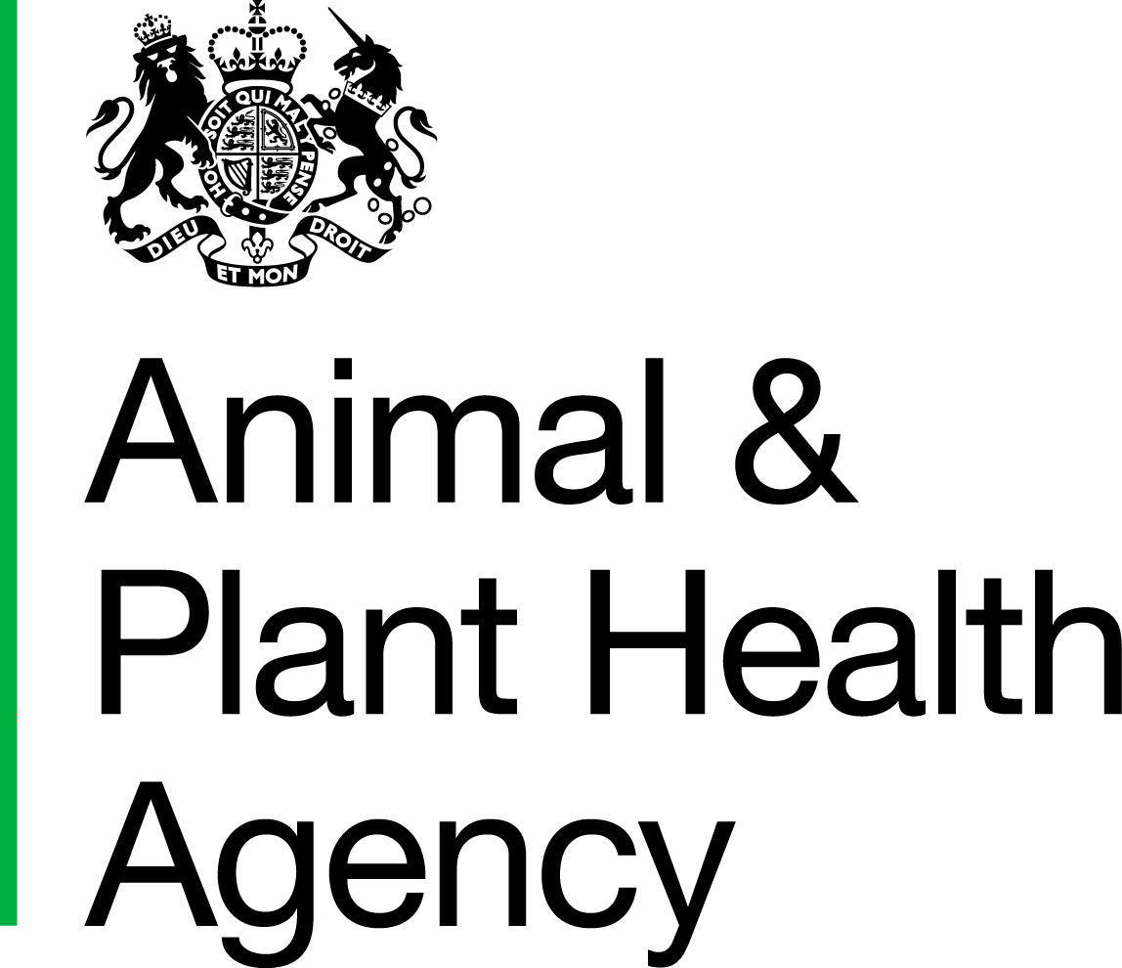
Required Method of Operation: Pet Travel Scheme: Airlines

Section 1 - General Information

Carrier: |  |  | Commercial
Date of Completion/Amendment: |  |  | Charter
RMOP Number
(to be given by APHA on approval):

Air Operators Certificate (AOC) number in name of Carrier
Mandatory review date (to be given by APHA - this must be completed in order to continue operating)

Carrier details:
Airport of arrival: | OXFORD
Are there limitations on flights accepting pets?

Staff involved in PETS Operations | Designation | Manager involved in PETS Operations (Name) | Designation | Contact No.
ASHLEY VALENTINE | TERMINAL MANAGER | ASHLEY VALENTINE | TERMINAL MANAGER | 01865 290600
ROSEMARY GREENOUGH | CUSTOMER SERVICE | ASHLEY VALENTINE | TERMINAL MANAGER | 01865 290600
AMANDA KELLY | CUSTOMER SERVICE | ASHLEY VALENTINE | TERMINAL MANAGER | 01865 290600
GEMMA KING | CUSTOMER SERVICE | ASHLEY VALENTINE | TERMINAL MANAGER | 01865 290600
EMMELINE DOLLING | CUSTOMER SERVICE | ASHLEY VALENTINE | TERMINAL MANAGER | 01865 290600
MELINDA HILL | CUSTOMER SERVICE | ASHLEY VALENTINE | TERMINAL MANAGER | 01865 290600

The above details must not be changed without giving notice to APHA Centre for International Trade - Carlisle (CITC). Written agreement must be obtained from CITC before any change is made.

Section 2 - Required Method of Operation (RMOP)

Operation | Description of the procedure/facility etc. | ‘X Reference’ | Staff Member(s) Responsible for Supervision
Check in Procedures
1.(i) Carriers are required through their booking systems to identify pets. | Pets will be taken directly to their aircraft with their owners by the relevant handling agent in departure airport. All animals will be pre-booked.  Bookings are all dealt with by (Name of Carrier)__________and the  (Name of Carrier)________office will be responsible for prenotifying  Oxfordjet Aviation Services at London Oxford Airport.  Pets i.e. Dogs and Cats under the (Pet Travel Scheme) PETS will not be  allowed on (Name of Carrier)_________flights into the UK without  authorisation from Oxfordjet.  No other animals will be carried into the UK unless  authorised by AH.  As soon as a booking is made the owner will be requested to send all  PETS paperwork to Oxfordjet at pets@oxfordjet.com or by fax +44 (0)1865  290661 to allow pre-checking and minimise problems on arrival. 24 hours  minimum notification prior to departure.  A satisfactory pre-check will not guarantee that the pet will pass the  PETS check on arrival. PETS would be taken directly to our aircraft with  their owners by the relevant handling agent in departure airport. Details  also recorded on the AH database. |  | ASHLEY VALENTINE
(ii) Records must be available and provided to APHA. | Records kept by (Name of Carrier)___________and AH.  Information will be forwarded to AH by Oxfordjet as required. Oxfordjet  record information in internal spreadsheet and store all paperwork in a file  with a separate section for each carrier. |  | ASHLEY VALENTINE
Routing of Travellers without Pets
2. The identification of undeclared pets carried by any traveller is an essential part of prevention of smuggling. Carriers should describe the instruction and training given to all staff at points in transit through the journey where illegal imports might be detected. Methods of redirection and enforcement should be described. | Travellers found evading the Check system will be dealt with as under the existing 1974 Order procedures.  Any undeclared pets would be detected by the flight crew due to the small  size of the aircraft cabins.  In the event that an undeclared pet was found onboard after take off the  flight crew would call Oxfordjet prior to arrival in the UK.  Oxfordjet would alert Customs, Local Authority and AH. |  | ASHLEY VALENTINE
Routing of Declared Pets
3. Carriers should describe how pets should be handled between check in and checks at destination. Detail should be given on how passengers with pets will be handled where pets are allowed to travel in the passenger cabin. On arrival at the airport of embarkation carrying crates must be marked in such a way that they are easily identified until they are cleared at the UK airport of entry. What method of marking will be used? | Cabin of aircraft seat a max of 14 passengers. The pet would be in the  cabin with the owners. |  | ASHLEY VALENTINE

Operation | Description of the procedure/facility etc. | ‘X Reference’ | Staff Member(s) Responsible for Supervision
UK Entry Clearance
4.(i) Describe where and who will be carrying out the pets checks.  (ii) How will travellers collect their pets? | If checks are carried out by an approved Checker on behalf of the airline, Section 4 must be completed.  Fax, pre-alert upon acceptance of reservation for cat/dog under PETS  Final alert on departure by (Name of Carrier)________to Oxfordjet to  arrange to meet pet on arrival.  (Name of Carrier)______ will contact Oxfordjet with location of aircraft  on landing. Trained uniformed staff will meet the aircraft where checks  will be carried out onboard the aircraft.  On arrival on Stand the pet will be kept on board until the arrival of  Oxfordjet PETS handling staff. Pets flying from non EU countries will  require customs clearance.  Once customs cleared (if applicable) PETS and owners will be escorted back to the terminal either on foot or in a vehicle by a member of  Oxfordjet staff. |  | ASHLEY VALENTINE

The above details must not be changed without giving notice to APHA CITC. Written agreement must be obtained from CITC before any change is made.

Section 3 - Acceptance of RMOP conditions

I am aware that all pets must comply with relevant Animal Welfare legislation and will comply with the IATA guidelines.

Signed for Carrier
Name in BLOCK LETTERS |  | Date:
Status/Designation: |  | Email address:

The above details must not be changed without giving notice to APHA CITC. Written agreement must be obtained from CITC before any change is made

Section 4 - Agreement by Approved Pets Checker to carry out Pets checks

I hereby agree to carry out the required checks on all pets as set out at point 4 of section 2 above.

Signature
Name in BLOCK LETTERS | ASHLEY VALENTINE | Date:
Name of Approval PETS Checker: | OXFORDJET | Email address:

Section 5: Delivery Team Recommendation

Signature |  | APHA office:
Name in BLOCK LETTERS |  | Date:
 | Veterinary Head of Field Delivery (VHoFD)

This form must be submitted for approval to the Import Team at CITC: email to Imports@apha.gsi.gov.uk

Section 6: Import Team approval:

Signature
Name in BLOCK LETTERS |  | Date:

FAIR PROCESSING NOTICE
Defra, the Scottish Government, the Welsh Government and the Food Standards Agency are Data Controllers in Common in respect of personal data processed by the Animal and Plant Health Agency (APHA). For the purposes and usage of the data by APHA and the data sharing arrangements, please see the APHA Personal Information Charter on GOV.UK. A hard copy of this can be provided if required; please contact your local APHA Field Service office. APHA will not permit any unwarranted breach of confidentiality or act in contravention of their obligations under the Data Protection Act 1998. APHA is an Executive Agency of the Department for Environment, Food and Rural Affairs and also works on behalf of the Scottish Government, Welsh Government and Food Standards Agency.

APHA is an Executive Agency of the Department for Environment, Food and Rural Affairs and also works on behalf of the Scottish Government, Welsh Government and Food Standards Agency to safeguard animal and plant health for the benefit of people, the environment and the economy.

HM3 Stamp | Name: |  | Date Received: |  | WS ID:

